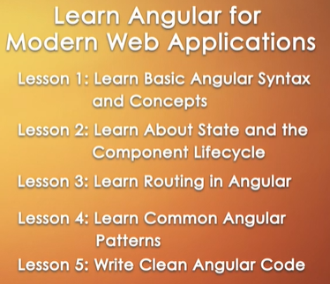

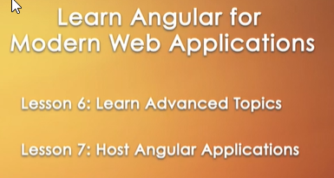

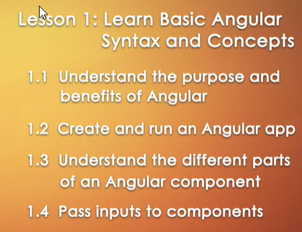

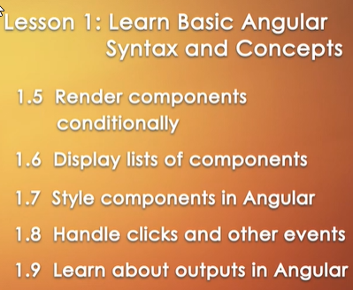





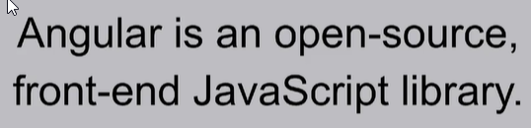

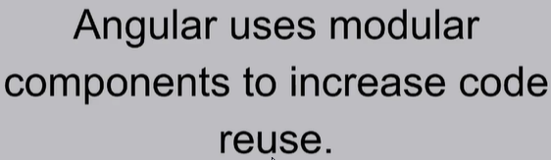



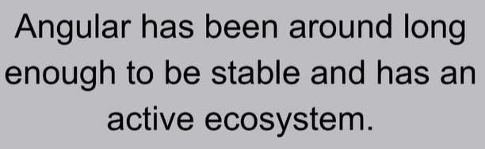



Angular: Framework, React: Library

Angular: right way to do a thing, React: Many ways to do same thing.



Much easier to transfer over gradually and used in case of existing web apps. Angular used when want to build from scratch.



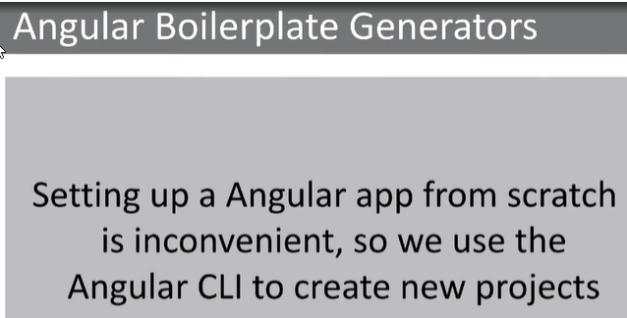

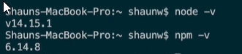

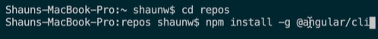

npm install -g @angular/cli









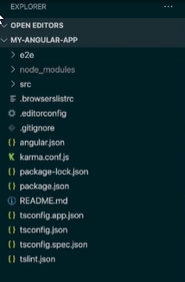

Setup done, Check version of node, npm, install angular cli, ng new my-angular-app, code. to launch vs code



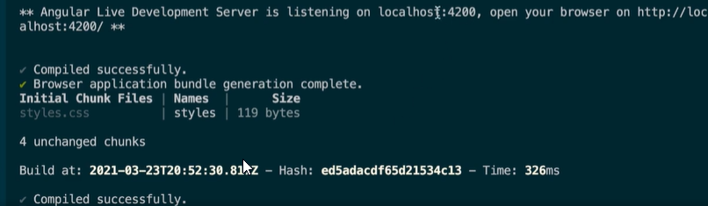

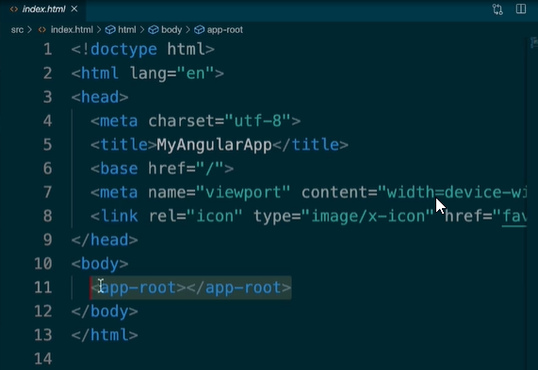

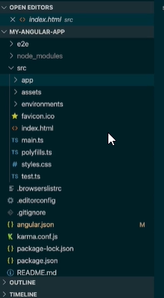

The whole app component is rendered inside the app-root tag inside index.html.

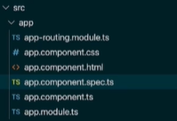

spec.ts: contains the tests for our components

routing.module.ts file: contains routing logic for our file



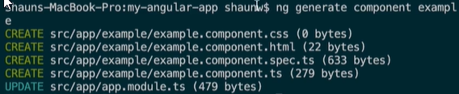

app.component delete all boilerplate code but keep the router-outlet, and paste the app-example.

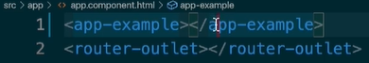



ng serve -o; opens automatically in a browser.

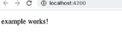

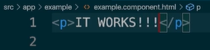

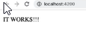

Hot reloading, automatically updates.

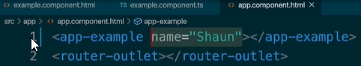

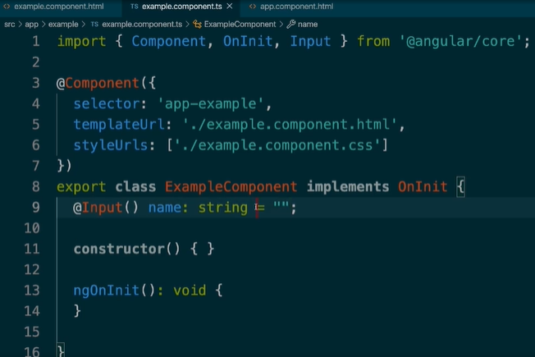How inputs/ Passing inputs to components look like.

Import Input in example.component.ts file, add 9th line

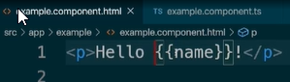

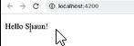

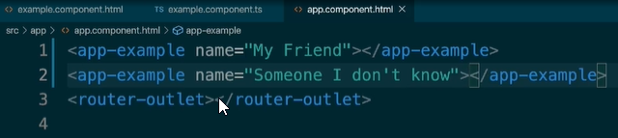

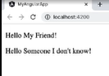



To hide certain components where we need to, we something called Structural- Directives in Angular.

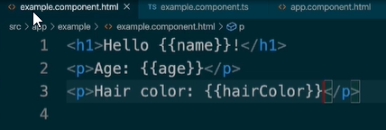

Display few attributes inside example.component.html

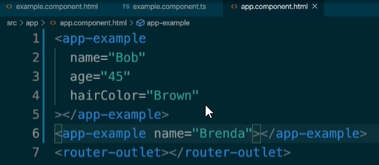

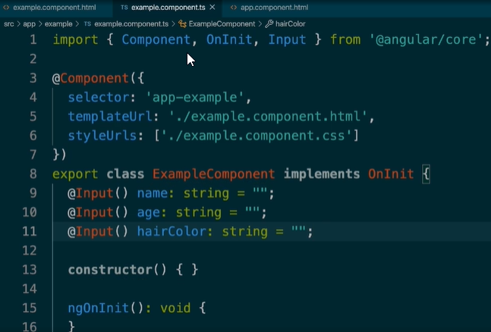

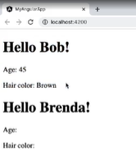

If we want to hide certain components like age or hair color if we did not pass any input for those,

We use structural directives, \*ngIf

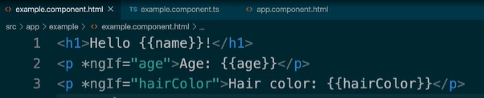

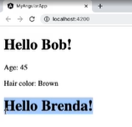

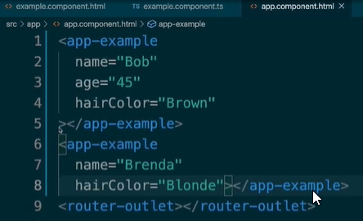

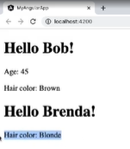

What if, no name is given, we just want to display Hello.

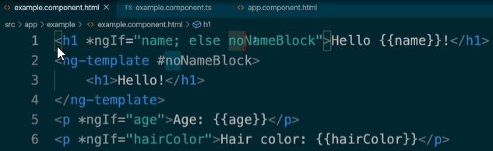

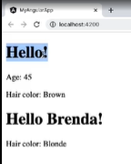If name exists display first element, else display noNameBlock template.

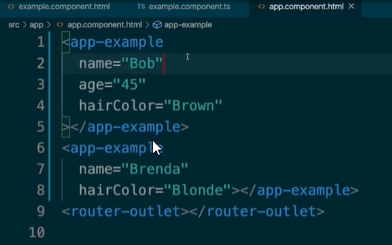

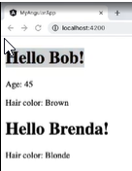

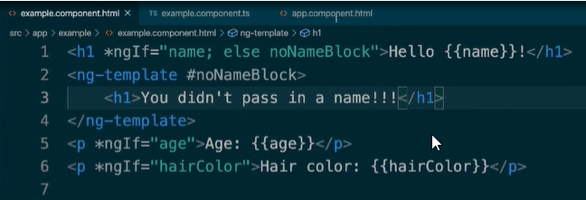



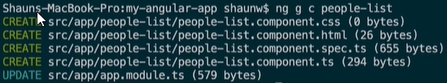If want to display a list of elements on the screen.

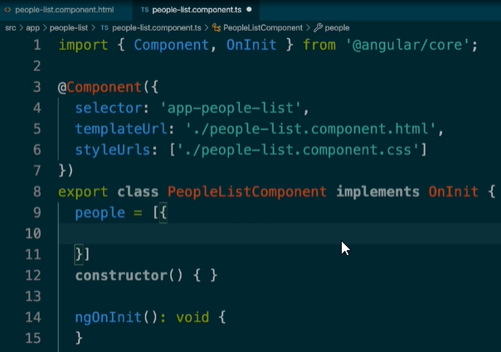Generates new component called people-list

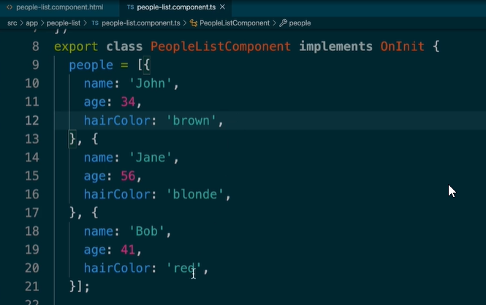

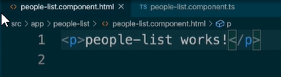

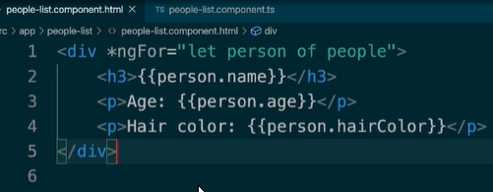

For each loop, using \*ngFor= “let person of people”

So now, we go to our app.component and display our people-list.component

Tag we get from the selector in ts file of people list component.

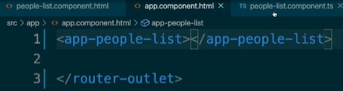

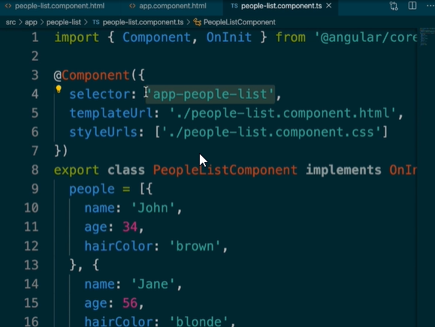



Restart using ng s, or ng start.

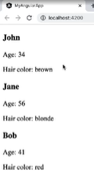

\*ngIf and \*ngFor cannot be used in the same line together.

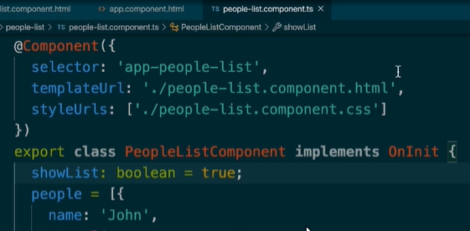



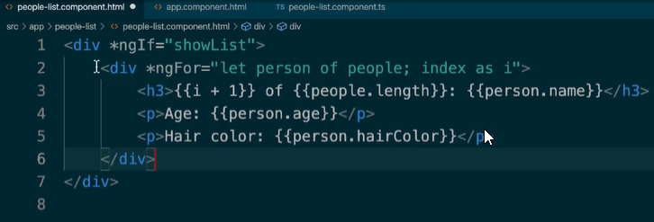

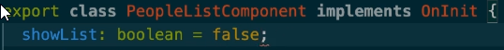

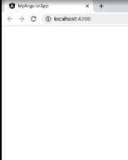

Boolean false hides our list, using ngif and ngfor nested and people list component.ts



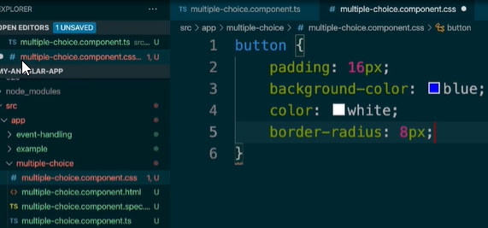

In a new component.

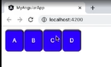

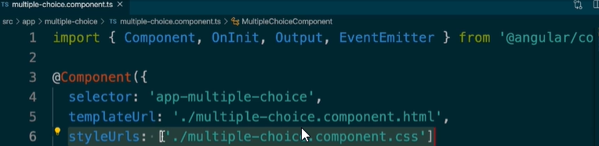

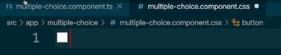

Remove styles

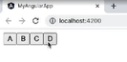

Styling goes back to normal.

Component specific styling, only apply to the specific DOM/component, if this css code is put inside app.component.css, styles will not show up, even though the multiple choice component is inside app component.

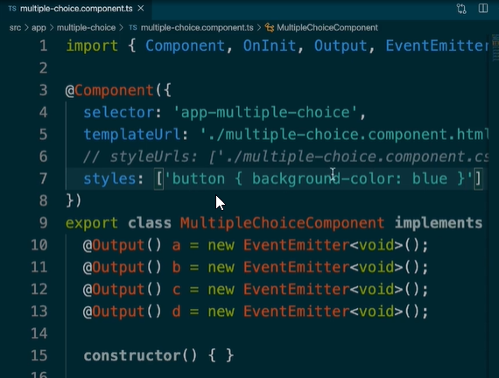

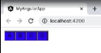Another way to define styles is inside our component decorator.

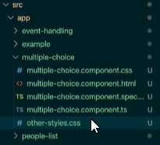In styleUrls, we can pass multiple file paths to it, if we want styles from several css files to be sort of combined.

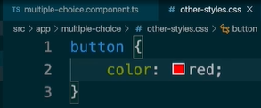

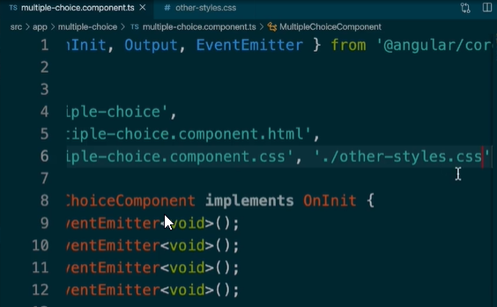

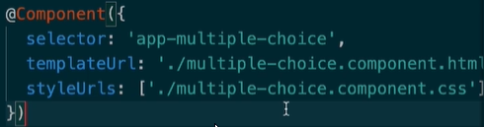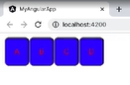





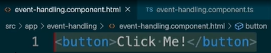

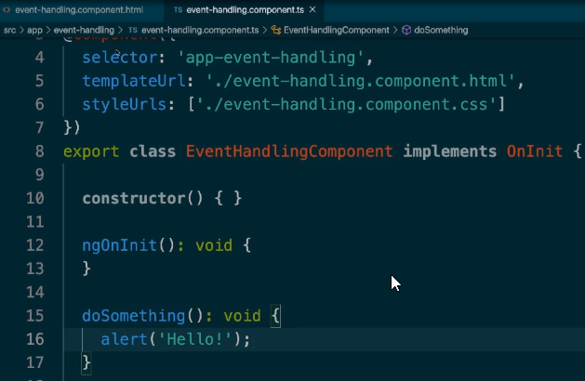

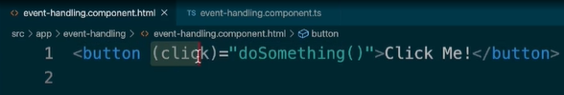Call the doSomething method, on click of the created button.

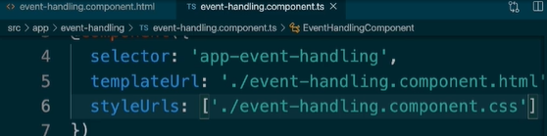

Open app.component and display the app-event-handling component inside.

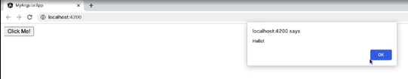

Obviously you can have multiple methods inside the EventHandlingComponent .ts file.

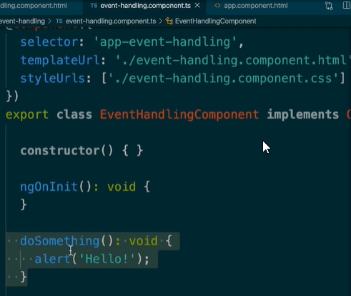

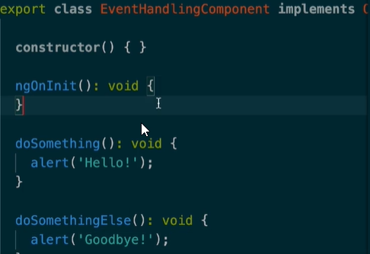

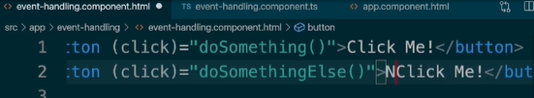

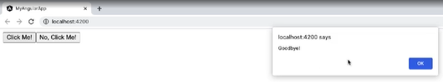

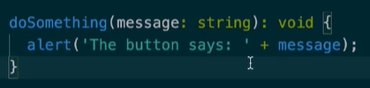

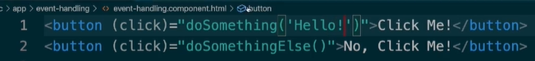

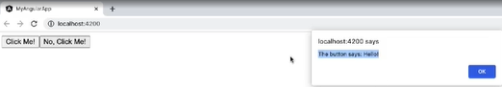

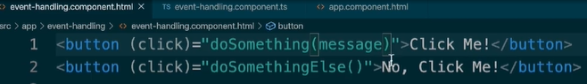

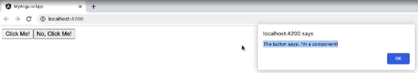

Basics behind basic event handling in Angular.

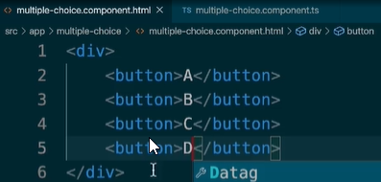

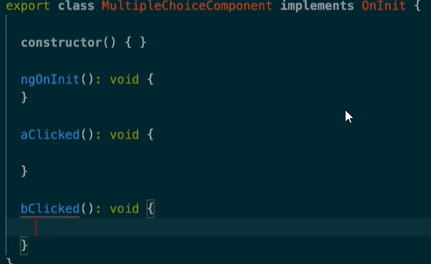

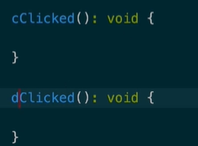In multiple-choice.component.ts

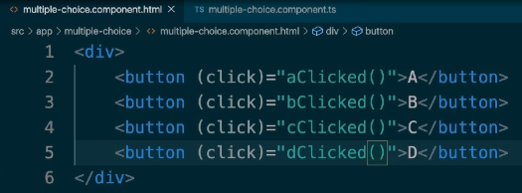

<button (click)=”aClicked()”>A</button>

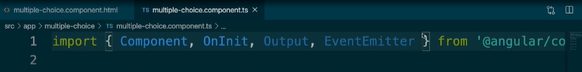

Import Output and Event Emitter.



In class inside .ts.

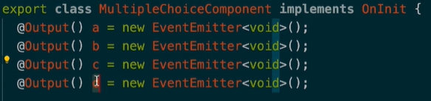

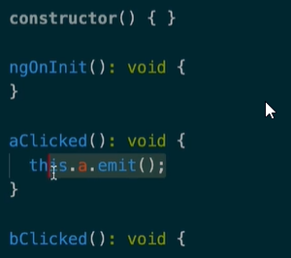

.emit() for all of the events.

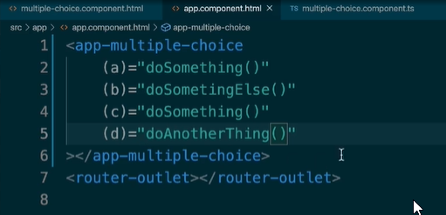

In app.component.html

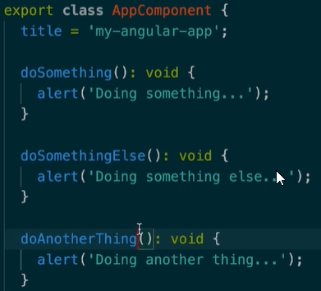

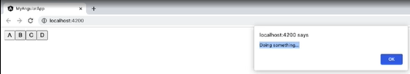

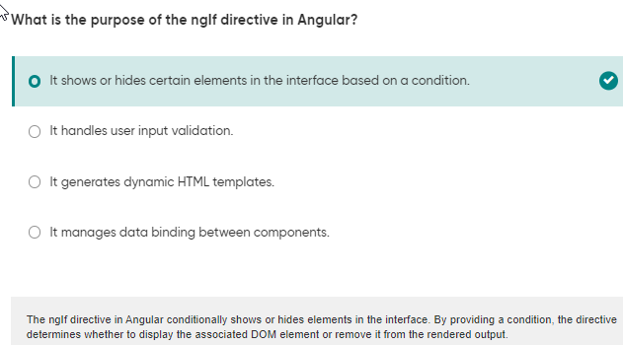

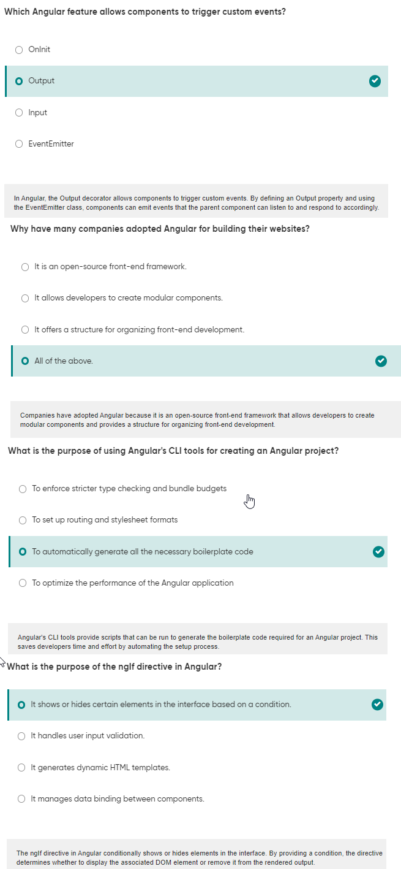



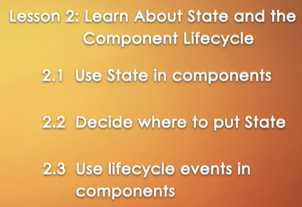



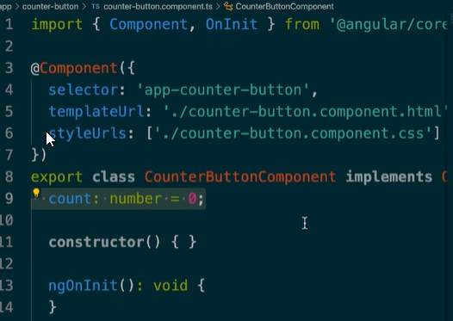

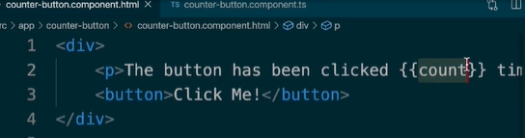

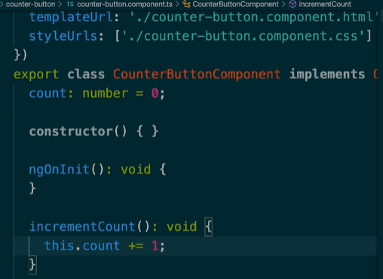

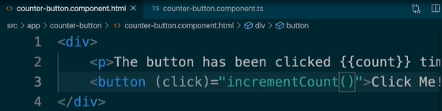

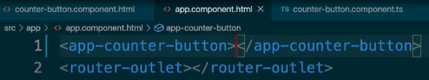

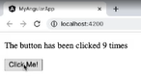Add in app.component.html

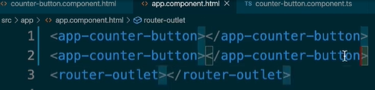

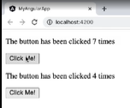



When certain number of times button has been clicked, want to show a specific message, in component outside the counter-button component.

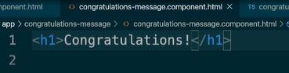

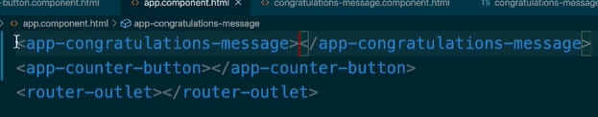

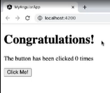

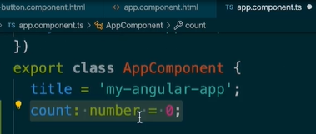

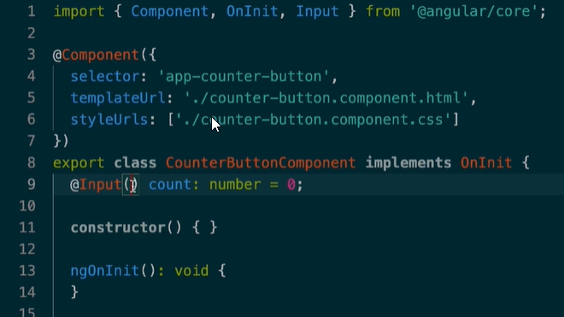Add count variable in AppComponent.ts

Import Input in cb component deleting other methods.

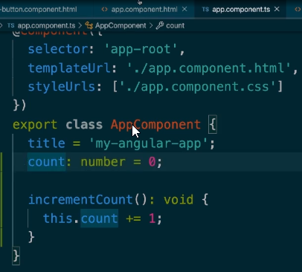Default value of number is 0.

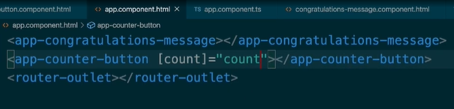

This is how we pass non numeric values as inputs.

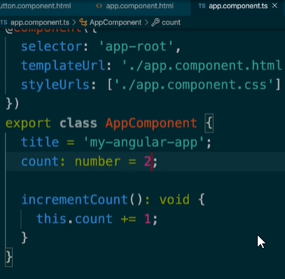

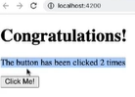

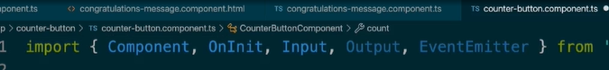

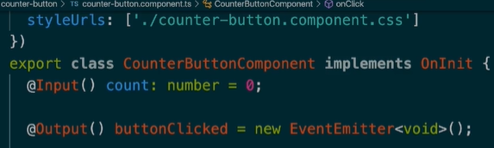Cb component, import both output and eventemitter.

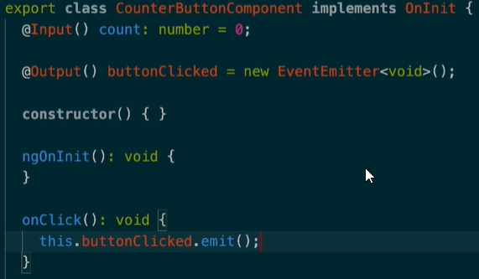

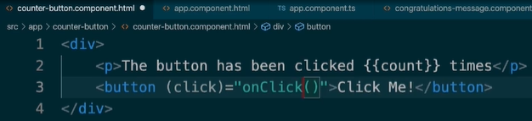Create a new event buttonClicked.

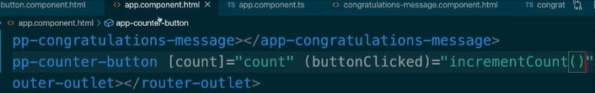Change function from onIncrement to onClick which triggers event buttonClicked.emit.

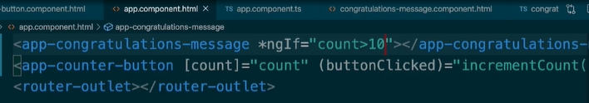

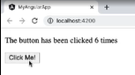

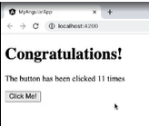

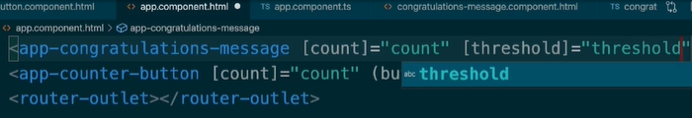

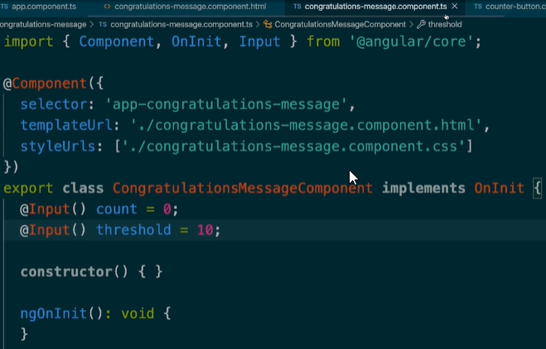

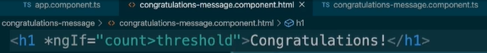

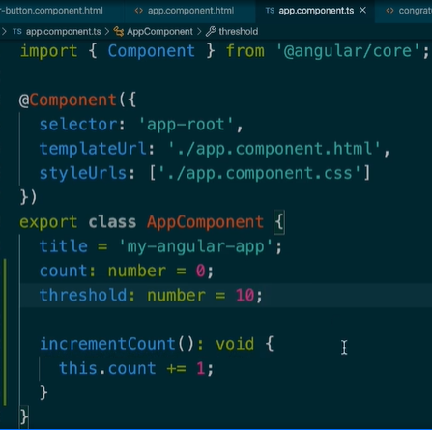

Appcomponent passes down its state for count and threshold both to congratulations-message and counter-button component.